**AUTOMATIC ROADPATCHING BOT**

By

Mohammad Furkan

B. Naga Vamsi Reddy

Manasa Murarisetty

Ruhani Rawal

Bhanu Mahesh

**Title**

________________________________________________________________________________________________________________________________________________________________________________________________________________________________________________________________________________________________________________________________________________________________________________________________________________________________________________________________________________________________________________________________________________________________________________________________________________________________________________________________________________________________

**Automatic Roadpatching bot** – a semi-automatic bot that uses video processing and sensor technology for hole and depth detection in road patches/potholes to carry out the road repair work.

Abstract

________________________________________________________________________________________________________________________________________________________________________________________________________________________________________________________________________________________________________________________________________________________________________________________________________________________________________________________________________________________________________________________________________________________________________________________________________________________________________________________________________________________________

Some of the major challenges of any infrastructure project, especially in highway and road repair, are human error and health issues faced by workers because of complete manual road patching or construction work. When you take on most construction projects, 100% accuracy is not achieved due human labour and the material used can cause harmful side-effects to the workers, like the plastic fumes produced can be fatal. These problems can be solved using a machine that is semi-automatic and can communicate through a transmitter/receiver. The machine should be made as such that it should automatically detect the holes on the given surface using sensors and perform the tasks like dusting, filling, rolling, cleaning, etc by itself. We can use various modern technologies and implement them in a machine to achieve this objective.

Introduction

________________________________________________________________________________________________________________________________________________________________________________________________________________________________________________________________________________________________________________________________________________________________________________________________________________________________________________________________________________________________________________________________________________________________________________________________________________________________________________________________________________________________

The automatic road patching bot is a machine that has been made to solve the various challenges faced in road repair. This robot uses technologies such as video processing to capture the video/images from the fitted camera for the detection of the patches on the road even for long distances. This robot uses ultrasonic sensors for hole and depth detection. The servos interfaced with the ultrasonic sensors then rotate according to the location detected and then the patching work is carried forward by the machine. The chemical composition used in this for the patching work is basically tar+plastic.

Literature

________________________________________________________________________________________________________________________________________________________________________________________________________________________________________________________________________________________________________________________________________________________________________________________________________________________________________________________________________________________________________________________________________________________________________________________________________________________________________________________________________________________________

**VIDEO PROCESSING-MATLAB**

Video processing consists in signal processing employing statistical analysis and video filters to extract information or perform video manipulation. Basic video processing techniques include trimming, image resizing, brightness and contrast adjustment, fade in and fade out, amongst others. Video applications present common but difficult challenges that require flexible analysis and processing functionality. Using MATLAB, you can develop solutions to common video processing challenges such as video stabilization, video mosaicking, target detection, and tracking. Video processing can be used to detect and count objects that move in video sequences.

COMPONENTS: -

**SENSORS- Ultrasonic Sensor**

An ultrasonic sensor is an electronic device that measures the distance of a target object by emitting ultrasonic sound waves, and converts the reflected sound into an electrical signal. Ultrasonic waves travel faster than the speed of audible sound (i.e. the sound that humans can hear). Ultrasonic sensors have two main components: the transmitter (which emits the sound using piezoelectric crystals) and the receiver (which encounters the sound after it has travelled to and from the target).

Ultrasonic sensors are used primarily as proximity sensors. They can be found in automobile self-parking technology and anti-collision safety systems. Ultrasonic sensors are also used in robotic obstacle detection systems, as well as manufacturing technology.

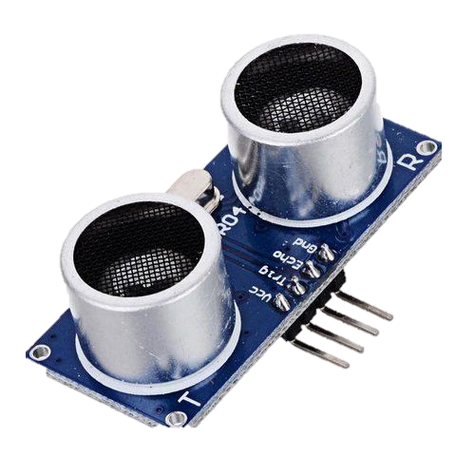

**Working Principle-** The ultrasonic sensor (or transducer) works on the same principles as a radar system. An ultrasonic sensor can convert electrical energy into acoustic waves and vice versa. The acoustic wave signal is an ultrasonic wave traveling at a frequency above 18kHz. The famous HC SR04 ultrasonic sensor generates ultrasonic waves at 40kHz frequency.

**Camera Sensor:**

A camera sensor is a piece of hardware inside the camera that captures light and converts it into signals which result in an image. Sensors consist of millions of photosites, or light-sensitive spots that record what is being seen through the lens. The size of the camera’s sensor determines how much of this light is used to create the image. camera sensor’s is basically a photo-sensitive site that captures light and color. This sensor has millions of these light-capturing cavities called "photosites." The camera transforms these photosites into pixels which make up your image.

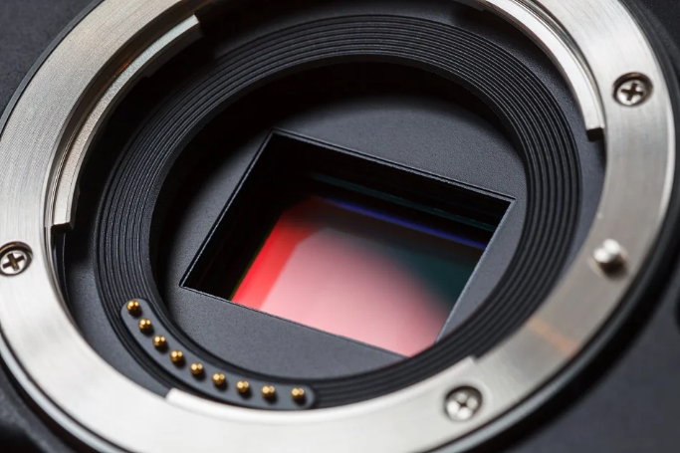

**Working Principle** -The image sensor in a camera system gets photon that is focused on using a lens otherwise optics. Based on the type of sensor like CCD / CMOS, the information will be transmitted to further stage like a voltage otherwise a digital signal.

The main function of the CMOS sensor is to change photons into electrons, after that to a voltage or digital value with the help of ADC (analog to digital converter).

**Transmitter/receiver:**

When a device sends out a wireless signal, it is called a transmitter. A transmitter is a necessary component of all electronic devices such as cell phones, television stations, ships etc. They are also used for navigation purposes. Receiver is an electronic device that receives signals and radio waves that are transmitted by the transmitter.

**ARDUINO**

Arduino UNO is a microcontroller board based on the ATmega328P. It has 14 digital input/output pins (of which 6 can be used as PWM outputs), 6 analog inputs, a 16 MHz ceramic resonator, a USB connection, a power jack, an ICSP header and a reset button. It contains everything needed to support the microcontroller; simply connect it to a computer with a USB cable or power it with a AC-to-DC adapter or battery to get started. The Uno board is the first in a series of USB Arduino boards.

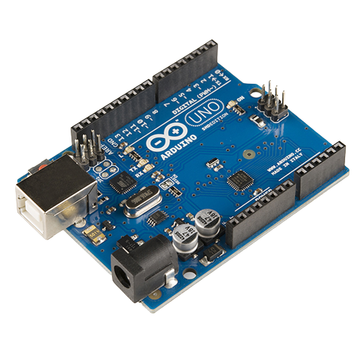

**Servo Motors**

A servo motor is a type of motor that can rotate with great precision. Normally this type of motor consists of a control circuit that provides feedback on the current position of the motor shaft, this feedback allows the servo motors to rotate with great precision. If you want to rotate an object at some specific angles or distance, then you use a servo motor. It is just made up of a simple motor which runs through a servo mechanism. It is a closed-loop system where it uses a positive feedback system to control motion and the final position of the shaft. Here the device is controlled by a feedback signal generated by comparing output signal and reference input signal.

**FILLING(CHEMICALS)**

The materials used for road construction in this project is extremely helpful to the environment The term bitumen which is also added to the mixture refers to a substance produced through the distillation of crude oil. Bitumen is known for its waterproofing and adhesive properties and is commonly used in the construction industry, notably for roads and highways. The ratio used of tar and plastic is 6:4.

**High Torque Motors**

A high torque motor is toroid shaped, like a donut, and thus has a large diameter and short axis. These motors can directly drive the application without additional mechanics, like worm wheels, belts or pulleys.

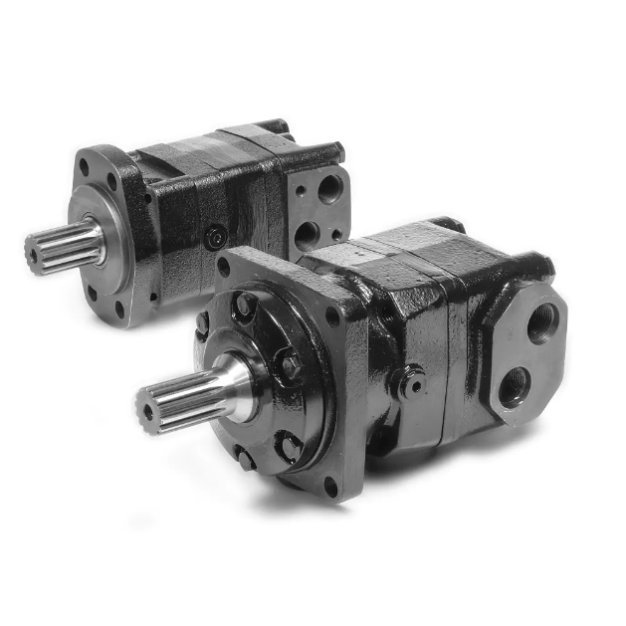

Working Methodologies

________________________________________________________________________________________________________________________________________________________________________________________________________________________________________________________________________________________________________________________________________________________________________________________________________________________________________________________________________________________________________________________________________________________________________________________________________________________________________________________________________________________________

**Circuit Diagram**

The basic functioning of detection and positioning of the machine is done by the ultrasonic sensors. The 4 ultrasonic sensors placed along the edge of the bot will detect the potholes/patches and the respective sensor will send the signal to the servo for the postioning which will then carry out the filling process. The ultrasonic sensors can also be used for depth detection. The limitations to this particular prototype is coded to detect potholes of upto 10cm. The coding for this done such that all four ultrasonic sensors are working simultaneously and sending signals according to detection. Interfacing for this is by connecting trig and echo pins to the digital pins of Arduino along with servo. The interfacing is done such that it has 5V and common ground. In the filling process we use the RC Radion Transmitter – Fly Sky to control the vehicle remotely.

**CAD Design**

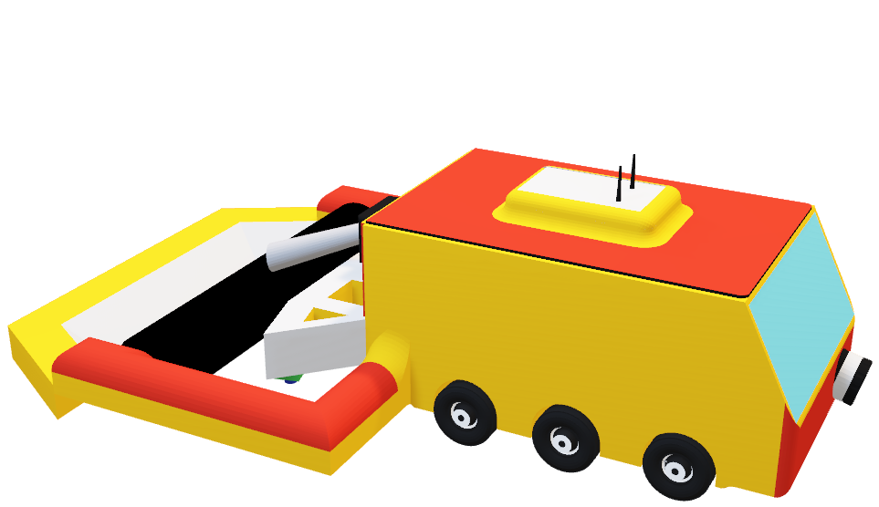

**Link for the Cad design –**

https://a360.co/3D9vFs9

**Video Processing**-

Video Processing is used for the detection of the holes from the front of the machine which is helpful for far distances, low light and also redirection of vehicle. Video captured from the camera sensor will be processed such that it will be converted into a Gray/b&w? video. It will then use edge detection from the video to identify the pothole. To successfully and efficiently complete this task noise cancellation is also done from the video. According to the hole and depth captured the machine can fill the pothole with the material required which is the tar and the plastic mixture. By video processing the operator can also do double checks, quality checks etc.

**Chemical Composition**

As previously mentioned, the chemical composition used for this is tar and plastic. For 10 tons of filling material 6 tons of tar and 4 tons of non-recyclable plastic. This is also beneficial to the environment as non-recyclable plastic is used for the process of road construction/reconstruction. Firstly, road making stones are heated upto 170 degrees Celsius. Then waste plastic which has been previously shredded is added to it. The plastic melts and binds with the stones in 30 seconds. Then bitumen is added to this mixture which is 160 degrees hot which is how the patching or road material is made.

Flowchart

________________________________________________________________________________________________________________________________________________________________________________________________________________________________________________________________________________________________________________________________________________________________________________________________________________________________________________________________________________________________________________________________________________________________________________________________________________________________________________________________________________________________

Conclusion

________________________________________________________________________________________________________________________________________________________________________________________________________________________________________________________________________________________________________________________________________________________________________________________________________________________________________________________________________________________________________________________________________________________________________________________________________________________________________________________________________________________________

The conclusion from this project is that various road construction/patchwork problems such as human error and harmful effects caused by physical labour can be solved using this semi-automatic road patching bot. This is a bot that is important, effective, efficient, environment friendly and costs less with respect to the filling material because waste recyclable plastic is used for filling in an appropriate amount. And since this robot is both automated and manual the operator can do this process till he is satisfied with the outcome of the road which helps with the end result.